Columbia Asia Hospital Project

Objective Questions:

1. In analyzing the hospital dataset with Power BI, ensure data cleaning to address inconsistencies and missing values before further analysis.

Before performing analysis in Power BI, the dataset was cleaned using Power Query Editor.

The following data cleaning steps were performed:

• Removed blank rows from the dataset.
• Checked and corrected data types such as date, patient_age, and patient_id.
• Renamed columns to maintain consistency and readability.
• Handled missing values (Null values) such as replacing missing satisfaction scores with appropriate values.
• Ensured that there were no incorrect or inconsistent records in the dataset.

These steps ensured that the data was accurate, consistent, and ready for further analysis and visualization in Power BI.

2. Assess the Average Waiting Time: Analyse the patient wait times to identify the average duration a patient spends before receiving care.

The average waiting time of patients was analyzed using the patient_wait time column in the dataset.

In Power BI, the AVERAGE aggregation function was used to calculate the average waiting time of patients before receiving care.

Average Waiting Time = AVERAGE(patient_wait time)

This metric helps the hospital understand how long patients typically wait before receiving medical attention. By analyzing this information, hospital management can identify delays in service and take steps to reduce waiting time and improve patient experience.

Insight :-
Analyzing the average waiting time helps hospital administrators improve operational efficiency and ensure that patients receive timely medical care.

3. Visits by Department Referral: Calculate the total number of visits to each department based on referrals to understand which departments are most frequently visited.

Approach:-
The total number of patient visits for each department was analyzed using the department_referral field.
A bar chart visualization was created in Power BI where department_referral was used as the axis and patient_id was counted as the value to measure the total visits per department.

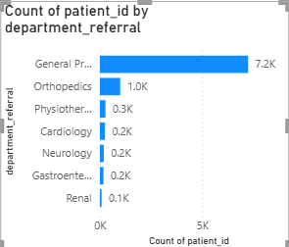

Observation:-
General Practice has approximately 7.2K visits, making it the most frequently visited department.
Orthopedics has around 1.0K visits. Other departments such as Physiotherapy, Cardiology, Neurology, Gastroenterology, and Renal receive comparatively lower patient visits.

Insight:-
The analysis shows that General Practice receives the highest number of patient visits compared to other departments.
Orthopedics also has a significant number of visits, while departments like Gastroenterology and Renal have relatively fewer visits.

Recommendation:-
The hospital management should allocate more doctors and resources to the General Practice department to handle the high patient load efficiently.
Departments with fewer visits can be analyzed further to understand whether awareness, accessibility, or service availability can be improved.

4.Patient Visits by Age Group: Segregate patient visits according to different age groups to see which demographics utilize healthcare services the most.
Approach:-
Patient visits were categorized into different age groups using the patient_age column.
A calculated column called Age Group was created to divide patients into groups such as 0–18, 19–35, 36–50, 51–65, and 65+.
A bar chart visualization was used in Power BI where Age Group was placed on the axis and patient_id was counted to measure total visits.
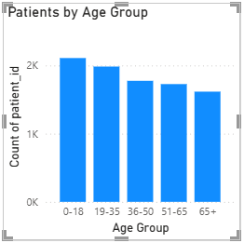
Observation:-
The 0–18 age group has the highest number of patient visits, followed by the 19–35 age group.
The number of visits gradually decreases as the age group increases, with the 65+ age group having the lowest number of visits.

Insight:-
The analysis shows that younger patients visit the hospital more frequently compared to older age groups.

Recommendation:-
The hospital should focus on improving pediatric and young adult healthcare services since these age groups contribute the highest number of visits.
Special preventive healthcare programs can also be introduced for older patients.

5.Were there any Null values in the data? What would be the best way to handle these Null values and which approach have you opted for?

Yes, there were some null values present in the dataset, particularly in the patient satisfaction score column. Null values represent missing or unrecorded data.
The best way to handle these null values is by either replacing them with an appropriate value (such as 0 or an average value) or removing them if they affect the analysis.
In this project, null values were handled during the data cleaning process in Power Query Editor by identifying and replacing them where necessary to ensure accurate analysis and visualization in Power BI.

6.Is there any relation between the number of visits and the Gender of the patients?

Approach:-
A pie chart was created in Power BI using patient_gender as the legend and count of patient_id as the value to analyze the relationship between gender and number of visits.

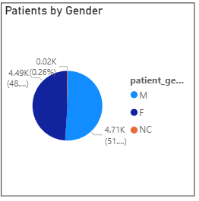

Observation:-
Male patients account for about 51% of the total visits, while female patients account for around 48%. A very small percentage belongs to the NC category.

Insight:-
This shows that healthcare services are utilized almost equally by both genders, with male patients visiting slightly more frequently than female patients.

Recommendation:-
Since both genders use hospital services almost equally, the hospital should ensure balanced healthcare facilities and services for both male and female patients.

7.Average Satisfaction by Demographics: Determine the relationship between patient satisfaction scores, their age groups, and racial backgrounds to pinpoint areas for improvement in patient experience.

Approach:-
The relationship between patient satisfaction, age group, and racial background was analyzed using a clustered column chart in Power BI. Age Group was used on the X-axis, patient_sat_score (Average) on the Y-axis, and patient_race as the legend to compare satisfaction levels across demographics.

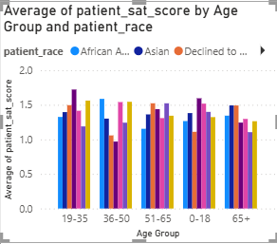

Observation:-
The chart shows that patient satisfaction scores vary slightly across different age groups and racial backgrounds. Some race groups report slightly higher satisfaction scores in certain age groups, while others show lower values.

Insight:-
Overall satisfaction levels appear relatively similar across most demographics, but small differences indicate that patient experience may vary depending on age and racial background.

Recommendation:-
The hospital should analyze the groups with lower satisfaction scores and identify possible issues such as service quality, waiting time, or communication to improve overall patient experience.

8.The hospital's managing director seeks to evaluate the revenue of each department to understand how much revenue is generated by each.
Approach:-
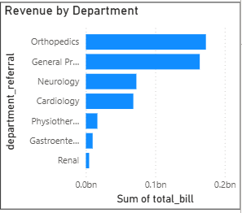

Observation:-
The chart shows that Orthopedics generates the highest revenue, followed by General Practice. Departments such as Neurology and Cardiology generate moderate revenue, while Physiotherapy, Gastroenterology, and Renal contribute the least revenue.

Insight:-
Higher revenue in Orthopedics and General Practice indicates that these departments receive more patient visits and treatments compared to others.

Recommendation:-
The hospital should ensure adequate staff and resources in high-revenue departments such as Orthopedics and General Practice to maintain service efficiency and patient satisfaction.

9.Which department is charging the highest appointment fees in general? Use an aggregation DAX function to solve this question.

Approach:-
A DAX measure was created using the AVERAGE function to calculate the average appointment fees from the appointment_fees column. A bar chart visualization was used where department_referral was placed on the axis and the calculated measure was used as the value to compare the average fees across departments.

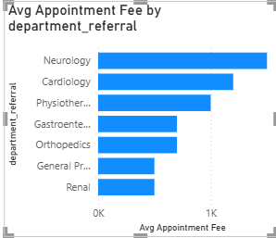

Observation:-
The chart shows that the Neurology department has the highest average appointment fees, followed by Cardiology and Physiotherapy. Departments such as General Practice and Renal have comparatively lower appointment fees.

Insight:-
Higher appointment fees in departments like Neurology and Cardiology may be due to specialized medical services and advanced treatments offered in these departments.

Recommendation:-
The hospital should ensure that higher appointment fees are justified with high-quality services and specialized care. At the same time, affordable healthcare options should be maintained in departments with lower fees to ensure accessibility for all patients.

10.Create a tabular visualization in the Report view which consists of Month-wise total visits in the hospital. Add a third column in the table that consists of the previous month’s total visits for each month’s row. Also, include a column that states whether the visits in a month are greater than that of the previous month's visits.

Approach:
A tabular visualization was created to analyze month-wise total patient visits in the hospital. A measure was used to calculate the previous month’s visits, and a comparison column was added to identify whether the current month’s visits were higher or lower than the previous month. This helped in understanding trends and variations in patient inflow over time.
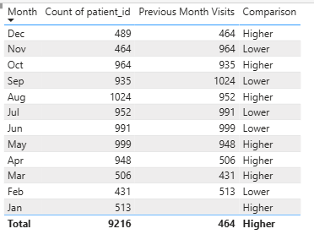
Observations:
The analysis shows that patient visits fluctuate across different months. Some months such as March, May, and October recorded higher visits compared to their previous months, while months like June, July, and November experienced a decline. There is no consistent upward or downward trend, indicating variability in patient inflow.
Insights:
The fluctuating trend suggests that hospital visits may be influenced by seasonal factors or external conditions. Periods of high patient inflow indicate increased demand for healthcare services, while low-demand periods may lead to underutilization of hospital resources.
Recommendations:
The hospital should allocate more staff and resources during high-demand months to manage increased patient load efficiently. During low-demand periods, promotional campaigns or health check-up offers can be introduced to improve patient inflow. Additionally, analyzing seasonal patterns in more detail can help in better planning and optimizing hospital operations.

11.Using ‘Calculate’ and a row iteration DAX function calculate the total number of patients who have visited Dr. Smith.

Approach:-
To calculate the total number of patients who visited Dr. Smith, a DAX measure was created using the CALCULATE function along with the FILTER row iteration function. The FILTER function iterates through the rows of the dataset and selects only those records where the doctor_name is "Dr. Smith". After filtering the rows, the COUNT function is applied on the patient_id column to determine the total number of patients who consulted Dr. Smith.
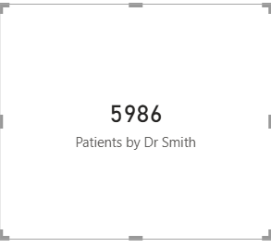
Insight:-
The analysis shows that 5986 patients visited Dr. Smith, indicating that Dr. Smith is one of the most frequently consulted doctors in the hospital.

Recommendation:-
Hospital management can monitor the workload of Dr. Smith and consider optimizing appointment schedules or distributing patients among other doctors to balance the workload and improve service efficiency.

12.Calculate the average age of the patients who visit the Orthopedics department. Will the approach used to calculate this metric be different if the requirement had been all departments’ average age?

Approach:-
To calculate the average age of patients visiting the Orthopedics department, a DAX measure was created using the CALCULATE function along with the AVERAGE aggregation function. The CALCULATE function filters the dataset to include only records where the department_referral is Orthopedics, and then the AVERAGE function calculates the mean value of the patient_age column.
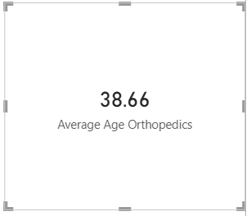

Insight:-
The analysis shows that the average age of patients visiting the Orthopedics department is approximately 38.66 years, indicating that most orthopedic consultations are from middle-aged patients.

Approach if requirement was all departments:-
Yes, the approach would be slightly different. Instead of filtering the dataset for a specific department, the AVERAGE function would be applied to the patient_age column for all records, or the department_referral field could be added to a visual to compare the average age across different departments.
13.Were there any data format issues in the data, and if there were/are how you handle them?

Approach:-
Yes, there were some data format issues in the dataset such as incorrect data types and inconsistent formatting in certain columns. During the data preparation stage in Power Query, the data types of important fields such as date, patient_age, patient_id, and numerical columns were verified and corrected. Columns representing numerical values were converted to Whole Number or Decimal Number, while the date column was converted to Date format to ensure proper time-based analysis.

Handling Method:-
To resolve these issues, the Transform Data (Power Query Editor) was used to clean and standardize the dataset. Data types were corrected, unnecessary columns were reviewed, and inconsistencies were fixed to ensure accurate analysis and visualization in Power BI.

Insight:-
Correcting the data format ensures that calculations, aggregations, and time-based visualizations work correctly, leading to more reliable insights from the dataset.

14.When we add a column in Power Query what’s the code that comes in M language in the formula bar? What do you know about M-query?
When a new column is added in Power Query, Power BI automatically generates M language code in the formula bar. The commonly used syntax is:
= Table.AddColumn(#"Previous Step", "New Column", each [Column_Name])
This code adds a new column to the existing table based on a specified logic.
M Query (Power Query M Language) is a functional programming language used in Power Query for data transformation and data preparation. It is used for operations such as filtering rows, changing data types, merging tables, adding or removing columns, and cleaning data.
Each transformation step performed in Power Query is automatically converted into M code, which helps automate the ETL process (Extract, Transform, Load) and ensures that the same transformations are applied whenever the data is refreshed.

15.Identify the top 5 doctors who generated the most revenue but had the fewest patients. (SQL)

APPROACH
Data was extracted from Power BI and exported into a CSV file. The CSV file was then imported into MySQL Workbench to create a structured table. SQL queries were applied using aggregation functions like SUM() and COUNT() to calculate total revenue and patient count for each doctor. The data was grouped by doctor_name and sorted using ORDER BY to identify the top 5 doctors based on highest revenue and lowest patient count.

SQL QUERY:-
SELECT
doctor_name,
SUM(total_bill) AS total_revenue,
COUNT(patient_id) AS total_patients
FROM sheet1data
GROUP BY doctor_name
ORDER BY total_revenue DESC, total_patients ASC
LIMIT 5;

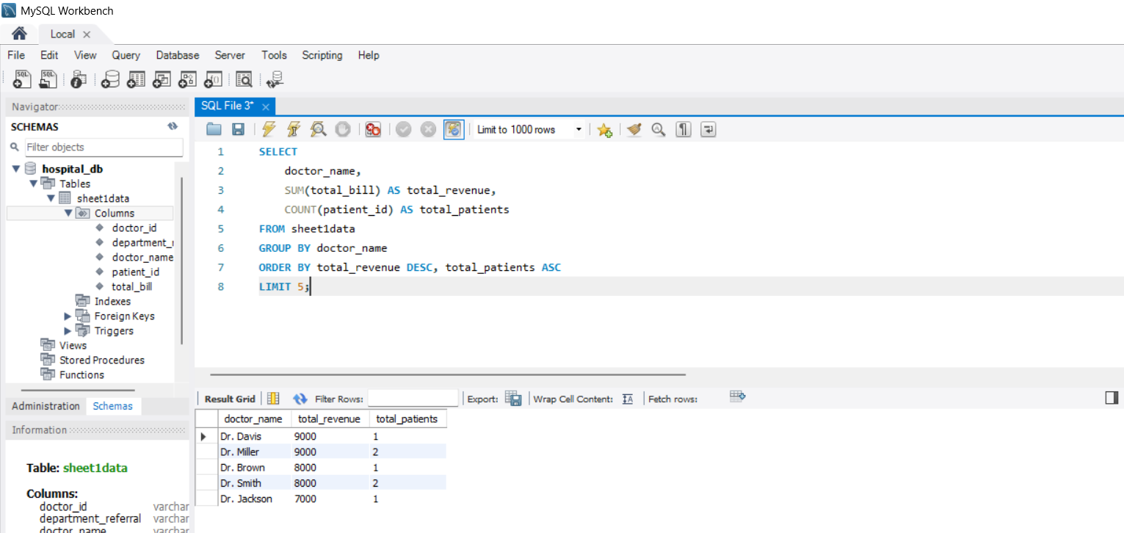

Observation
- Dr. Davis handled only 1 patient but generated the highest revenue.
- Dr. Miller handled more patients (2) but achieved the same revenue as Dr. Davis.
- Dr. Brown and Dr. Smith have equal revenue (8000) but different patient counts.
- Dr. Jackson has the lowest revenue among the top 5 doctors.

Insight
- Dr. Davis and Dr. Miller generated the highest revenue (9000), but Dr. Davis treated fewer patients, indicating higher efficiency.
- Doctors with the same revenue show differences in patient count, highlighting variation in revenue per patient.
- Some doctors generate high revenue with fewer patients, suggesting higher consultation or treatment charges.

Recommendation
- Focus on high-efficiency doctors like Dr. Davis to understand their pricing or treatment strategy.
- Improve revenue generation strategies for doctors handling more patients but earning less per patient.
- Balance workload among doctors to optimize both patient handling and revenue.
- Use these insights to improve hospital revenue planning and doctor performance evaluation.

16.Find the department where the average waiting time has decreased over three consecutive months. (SQL)

Approach (Updated with Power BI + SQL)
We first loaded the dataset into Power BI and performed data transformation.
A new column Month was created using the appointment date, and a measure Avg_Waiting was calculated using average patient waiting time.
We then created a table visual in Power BI containing Department, Month, and Average Waiting Time, and exported this processed data as a CSV file.
Next, the CSV file was imported into MySQL Workbench as a table (hospital_er).
Using SQL window functions (LAG), we compared the average waiting time across consecutive months for each department.
Finally, we filtered the records where waiting time decreased continuously over three months.
SQL QUERY:-
SELECT DISTINCT department_referral
FROM (
SELECT
department_referral,
Month,
Avg_Waiting,

LAG(Avg_Waiting,1) OVER
(PARTITION BY department_referral ORDER BY
FIELD(Month,'Jan','Feb','Mar','Apr','May','Jun','Jul','Aug','Sep','Oct','Nov','Dec')
) AS prev1,

LAG(Avg_Waiting,2) OVER
(PARTITION BY department_referral ORDER BY
FIELD(Month,'Jan','Feb','Mar','Apr','May','Jun','Jul','Aug','Sep','Oct','Nov','Dec')
) AS prev2

FROM hospital_er
) t
WHERE Avg_Waiting < prev1
AND prev1 < prev2;
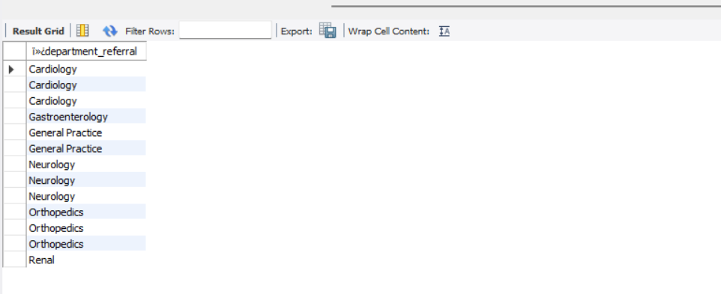

Observations
- Some departments improved patient handling efficiency over time.
- The decreasing trend suggests better scheduling, resource allocation, or process improvements.
- Multiple departments achieved this trend, showing overall hospital performance improvement.

Insights
The following departments showed a consistent decrease in average waiting time over three consecutive months:
- Cardiology
- Gastroenterology
- General Practice
- Neurology
- Orthopedics
- Renal
This indicates improved operational efficiency in these departments during certain time periods.

Recommendations
- Identify strategies used by these departments and apply them to others.
- Continue monitoring waiting time trends monthly.
- Implement staff optimization and better appointment management in departments with higher waiting times.
- Use predictive analysis to maintain low waiting times in future.
17.Determine the ratio of male to female patients for each doctor and rank the doctors based on this ratio. (SQL)

Approach
The dataset was first loaded into Power BI where relationships were created between relevant tables using the patient_id column. Measures were created to calculate the number of male and female patients treated by each doctor using conditional aggregation. A ratio of male to female patients was then calculated, and doctors were ranked based on this ratio using DAX functions.
The processed data was then exported and imported into MySQL Workbench. In SQL, the ratio was calculated using aggregate columns, and ranking was performed using the RANK() window function.
SQL QUERY
SELECT
doctor_name,
Male_Count,
Female_Count,

ROUND(Male_Count / NULLIF(Female_Count,0), 2) AS ratio,

RANK() OVER (
ORDER BY Male_Count / NULLIF(Female_Count,0) DESC
) AS rank_position

FROM doctor_name;
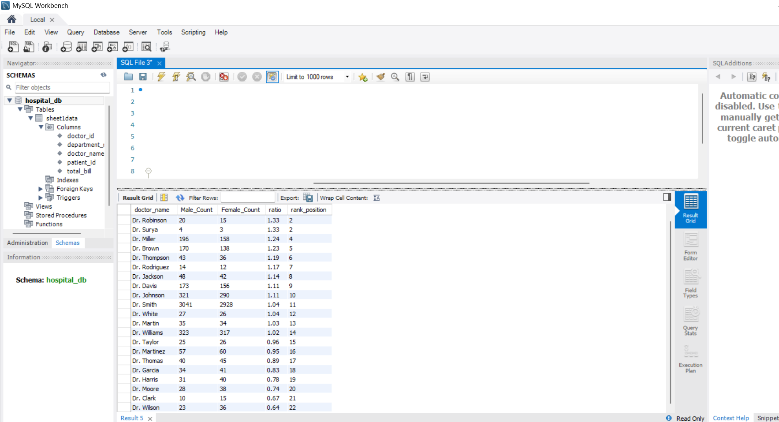

Observation
It was observed that some doctors have a higher ratio of male patients compared to female patients, while others have a balanced or lower ratio. For example, certain doctors like Dr. Robinson and Dr. Surya have a higher male-to-female ratio, whereas doctors like Dr. Wilson have a lower ratio.

Insights
The variation in the ratio indicates that different doctors may be handling different types of cases or patient demographics. A higher ratio suggests that a doctor is treating more male patients, while a lower ratio indicates a higher number of female patients. This could be influenced by specialization, department, or patient preferences.

Recommendation
The hospital should monitor gender distribution across doctors to ensure balanced patient handling. If any imbalance is observed, appropriate steps such as workload redistribution or specialization-based allocation can be implemented. Additionally, understanding patient preferences can help improve service quality and patient satisfaction.

18.Calculate the average satisfaction score of patients for each doctor based on their visits. (SQL)
Approach
The dataset was first analyzed in Power BI where doctor-wise average satisfaction scores were calculated using DAX. A measure was created using the AVERAGE() function on the patient satisfaction score column. A table visual was used to display each doctor along with their average satisfaction score and sorted in descending order.
Since the satisfaction score was not available in the original SQL table, the processed data from Power BI was exported and imported into MySQL. SQL was then used to validate and retrieve the same results.
SQL QUERY :-
SELECT
doctor_name,
ROUND(AVG(avg_satisfaction), 2) AS avg_satisfaction
FROM avg_satisfaction
GROUP BY doctor_name
ORDER BY avg_satisfaction DESC;

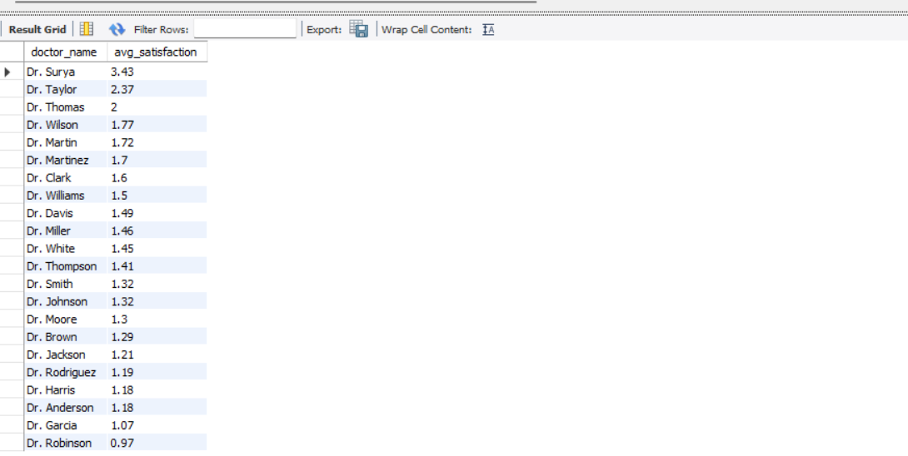

Observation
It is observed that there is a significant variation in satisfaction scores among doctors. Dr. Surya has the highest average satisfaction score, followed by Dr. Taylor and Dr. Thomas. On the other hand, doctors like Dr. Robinson and Dr. Garcia have comparatively lower satisfaction scores.

Insights
Doctors with higher satisfaction scores are likely delivering better patient experience, communication, and service quality. Lower scores may indicate issues such as longer waiting times, communication gaps, or patient dissatisfaction. The variation highlights differences in performance across doctors.

Recommendation
The hospital should identify top-performing doctors and adopt their best practices across departments. Doctors with lower satisfaction scores should be provided with training and feedback to improve patient interaction and service quality. Regular monitoring of satisfaction scores can help maintain consistent healthcare standards.

19.Find doctors who have treated patients from different races and calculate the diversity of their patient base. (SQL)

Approach
The dataset was first analyzed in Power BI where relationships were established using the patient_id field between relevant tables. A measure was created using the DISTINCTCOUNT() function to calculate the number of unique races treated by each doctor. A table visual was created to display doctor-wise race diversity along with total number of patients handled.
To further validate the results, the processed data was exported from Power BI and imported into MySQL. In SQL, the diversity of the patient base was calculated using COUNT(DISTINCT patient_race) grouped by doctor_name.
SQL QUERY:-
SELECT
doctor_name,
Race_Diversity,
Total_Patients
FROM `different races`
ORDER BY Race_Diversity DESC;

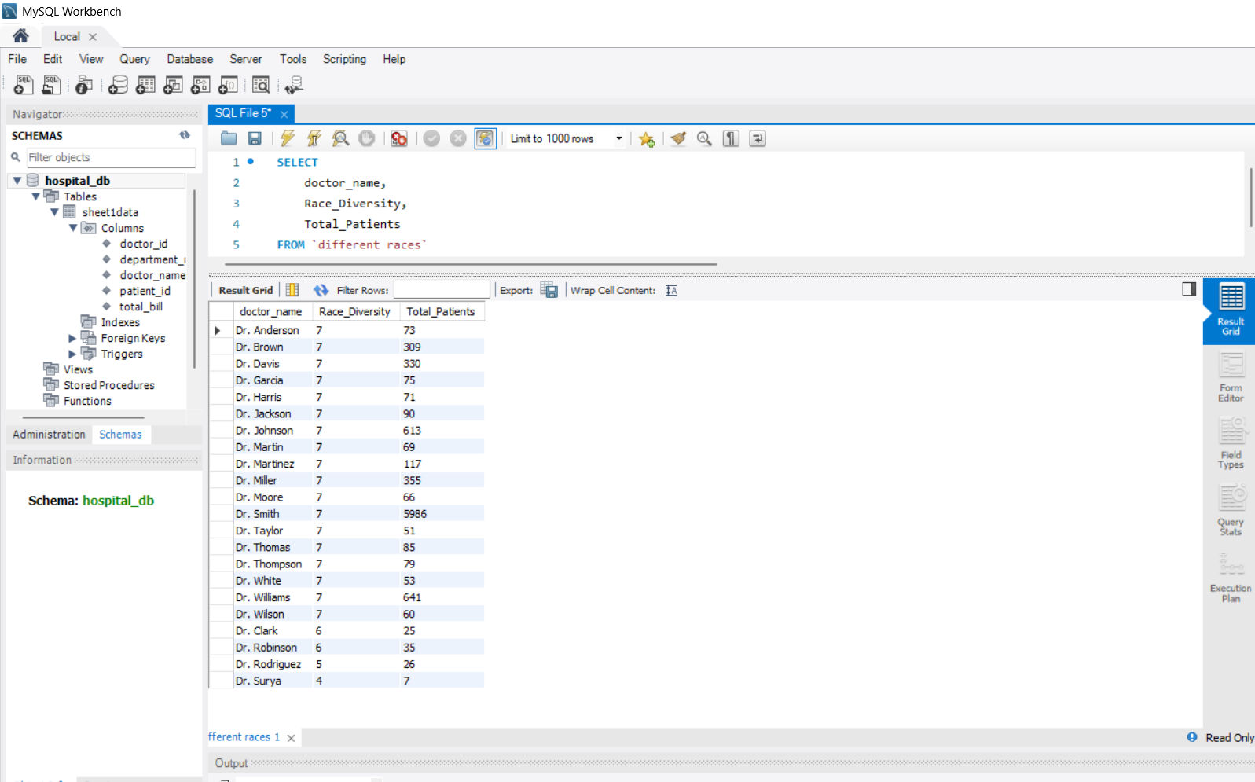

Observation
It is observed that most doctors have treated patients from multiple races, with several doctors having a race diversity score of 7, indicating a highly diverse patient base. Doctors such as Dr. Smith and Dr. Williams have handled a significantly higher number of patients compared to others.

Insights
A high race diversity score indicates that doctors are treating patients from a wide range of backgrounds, reflecting inclusivity and broad patient reach. Doctors with both high diversity and high patient count demonstrate strong experience and exposure to varied patient demographics.

Recommendation
The hospital should promote practices that support inclusive healthcare and equal treatment across all patient groups. Doctors with high diversity exposure can be utilized in training programs to share best practices. Additionally, analyzing diversity alongside patient satisfaction can provide deeper insights into service quality.

20.Calculate the ratio of total bills generated by male patients to female patients for each department. (SQL)

Approach
The analysis was first performed in Power BI by creating measures to calculate the total billing amount separately for male and female patients using the CALCULATE function. The ratio between male and female billing was computed using the DIVIDE function. A table visual was then created to display department-wise comparison.
The processed data was exported from Power BI and imported into MySQL. In SQL, the ratio was recalculated using arithmetic operations and NULLIF to avoid division by zero errors.
SQL QUERY:-
SELECT
department_referral,
Male_Bill,
Female_Bill,
ROUND(Male_Bill / NULLIF(Female_Bill, 0), 2) AS bill_ratio
FROM bill
ORDER BY bill_ratio DESC;
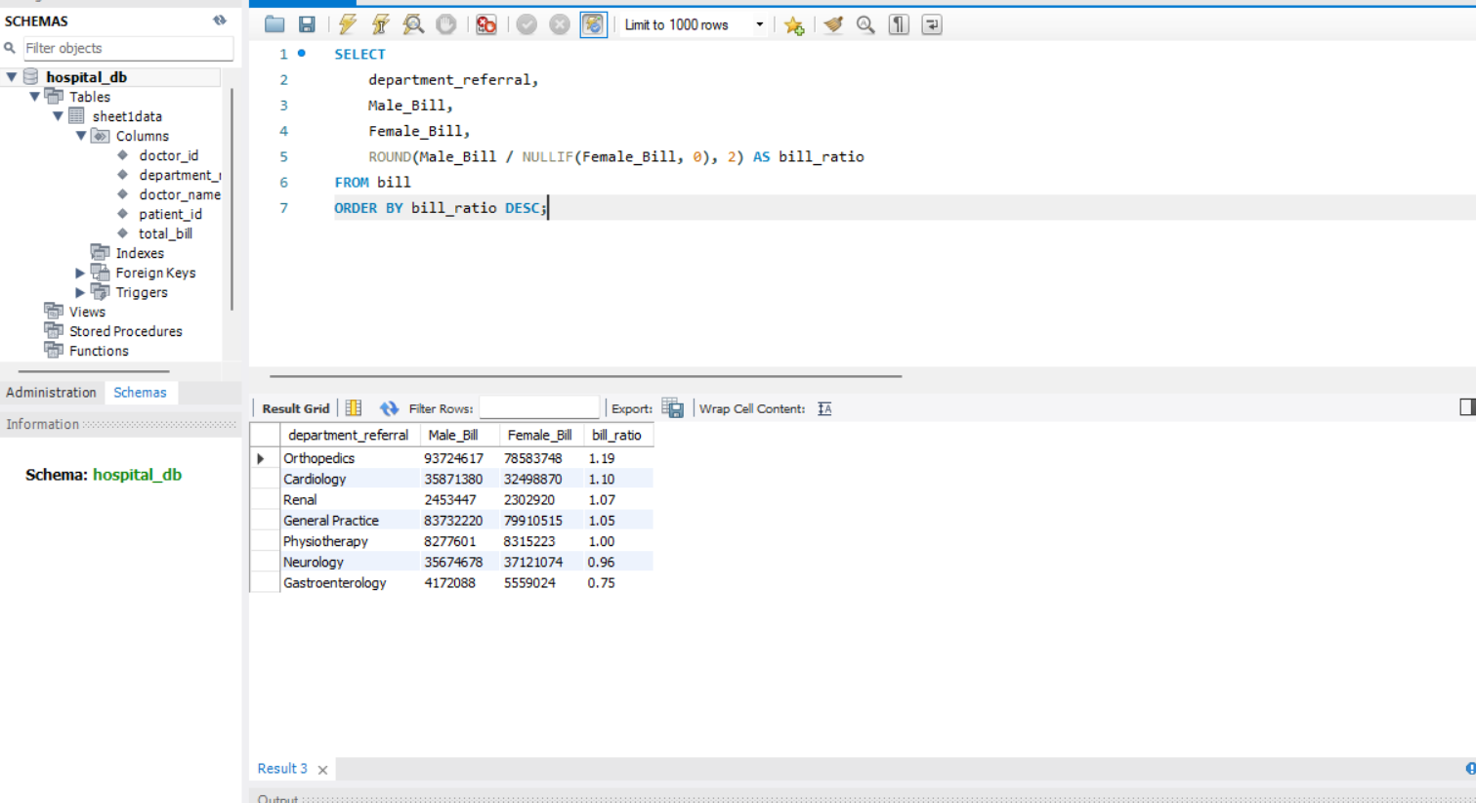

Observation
The Orthopedics department shows the highest ratio (~1.19), indicating higher billing from male patients. Gastroenterology shows a lower ratio (~0.75), indicating higher billing from female patients.
Insights
Departments with ratios greater than 1 indicate higher revenue contribution from male patients, while values below 1 indicate higher contribution from female patients. Balanced departments (ratio ≈ 1) indicate equal contribution.

Conclusion
The analysis highlights gender-based revenue distribution across departments. This insight can help hospitals optimize resource allocation and understand patient demographics more effectively.

21.Update the patient satisfaction score for all patients who visited the "General Practice" department and had a waiting time of more than 30 minutes. Increase their satisfaction score by 2 points, but ensure that the satisfaction score does not exceed 10. (SQL)
APPROACH:
- Data was first loaded into Power BI for analysis and visualization.
- A calculated column was created using DAX to simulate the updated satisfaction score based on conditions.
- The same logic was then implemented in SQL using an UPDATE query.
- Safe update mode was disabled to allow modifications.
- Data was filtered for patients in the General Practice department with waiting time greater than 30 minutes.
- LEAST function was used to ensure the satisfaction score did not exceed the maximum limit of 10.
- Final results were verified using SELECT queries.
SQL QUERY:-
SELECT
patient_id,
department_referral,
patient_waittime,
patient_sat_score
FROM `general practice`
WHERE patient_waittime > 30;

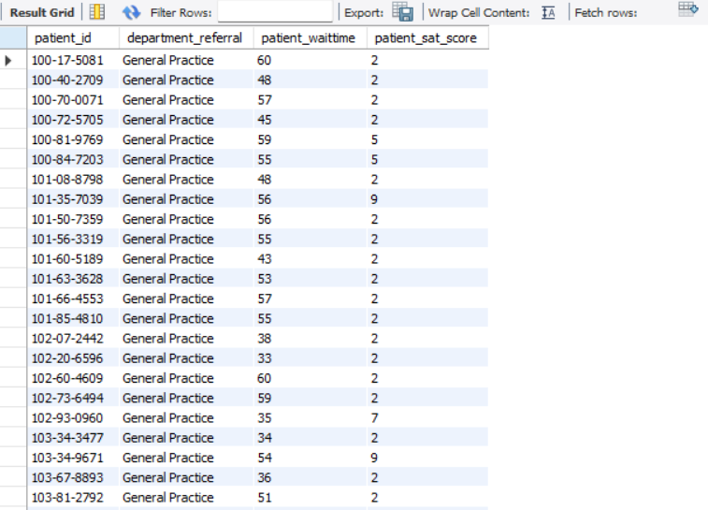

OBSERVATION:
- Patients with waiting time greater than 30 minutes showed an increase in satisfaction score.
- Scores were correctly incremented by 2 points.
- No value exceeded the maximum limit of 10.
- A large number of records (4000+ rows) were successfully updated.
- Data consistency was maintained across Power BI and SQL outputs.

INSIGHTS:
- Higher waiting time negatively impacts patient satisfaction.
- Providing compensation (score increase) improves overall satisfaction metrics.
- Departments with longer waiting times may require operational improvements.
- Data-driven updates help in maintaining fair evaluation systems.

RECOMMENDATION:
- Reduce patient waiting time through better scheduling and resource allocation.
- Regularly monitor satisfaction scores using dashboards.
- Implement automated updates or rules for performance evaluation.
- Clean dataset (remove encoding issues) before analysis for better accuracy.
- Use Power BI for continuous monitoring and SQL for backend data updates.

Subjective Questions

1.What is the relation between patient wait time and satisfaction scores?

Approach:
- A scatter plot was created using patient_waittime on the X-axis and average patient_sat_score on the Y-axis.
- A trend line was added to identify the relationship.
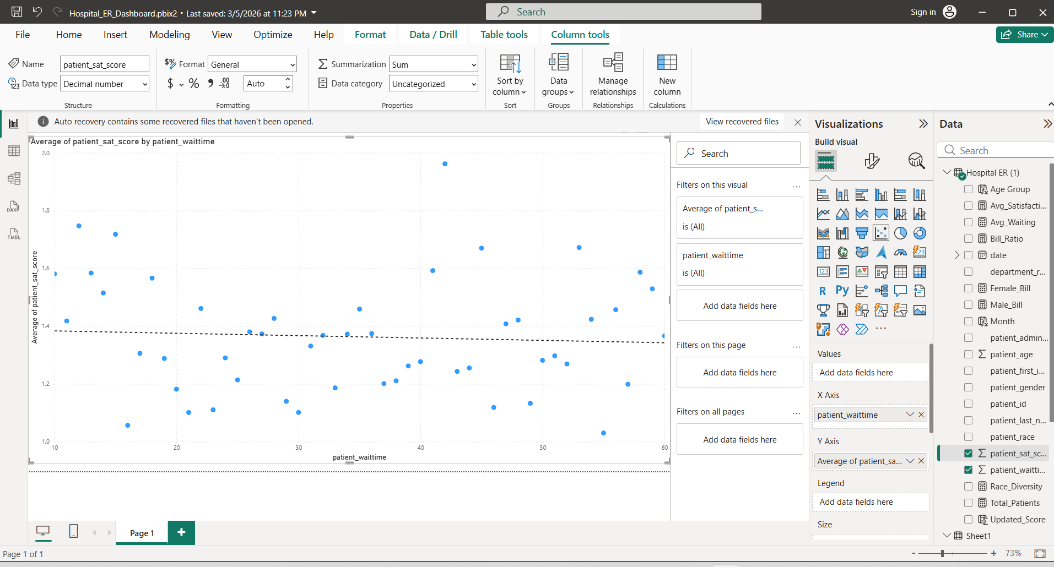

Observation:
- The trend line shows a slight downward slope.
- As waiting time increases, the satisfaction score tends to decrease.

Insight:
- There is a negative relationship between patient wait time and satisfaction.
- Longer waiting times lead to reduced patient satisfaction.

Recommendation:
- Reduce waiting time to improve patient satisfaction.
- Optimize hospital workflow and staffing during peak hours.
- How do patient demographics affect the frequency of visits to different departments?
2.How do patient demographics affect the frequency of visits to different departments?

Approach:
- A clustered column chart was created in Power BI using department_referral on the X-axis and count of patient_id on the Y-axis.
- Age Group was used as a legend to compare visit frequency across departments.
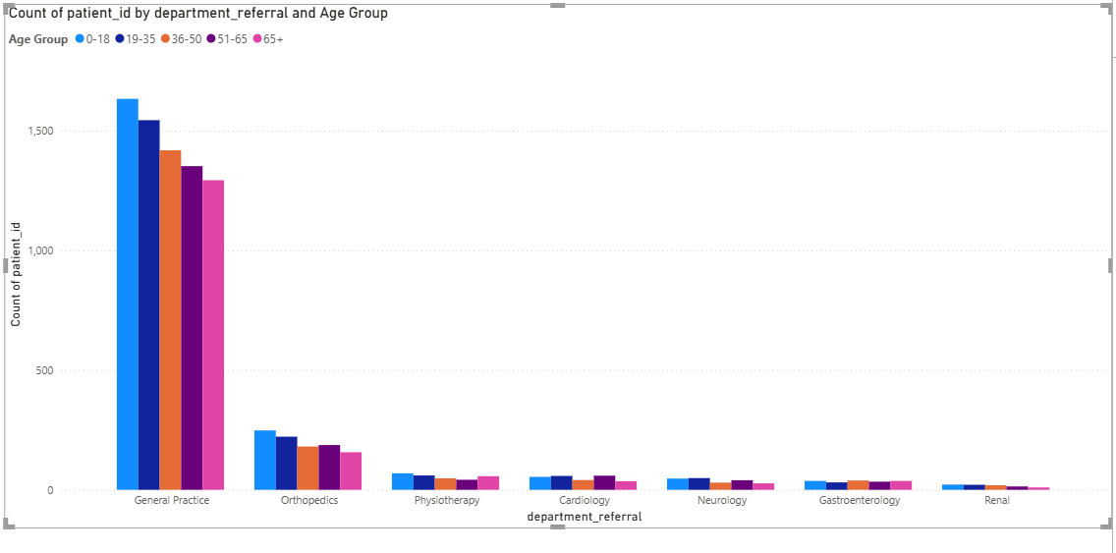

Observation:
- General Practice has the highest number of visits across all age groups.
- Orthopedics and Cardiology have moderate visits, especially from middle-aged and older patients.
- Specialized departments like Neurology and Renal have relatively fewer visits.

Insight:
- Younger age groups (0–18, 19–35) visit General Practice more frequently.
- Older age groups (36–50, 51–65, 65+) tend to visit specialized departments such as Orthopedics and Cardiology.
- Patient demographics significantly influence department visit patterns.

Recommendation:
- Allocate more resources to General Practice due to high demand.
- Provide specialized care and staffing in departments frequently visited by older patients.
- Use demographic insights to optimize hospital operations and patient flow.

3.Is there a noticeable trend in the volume of patient visits throughout the year?

Approach:
- A line chart was created using Month on the X-axis and count of patient_id on the Y-axis.
- The Month column was sorted using Month Number for correct chronological order.
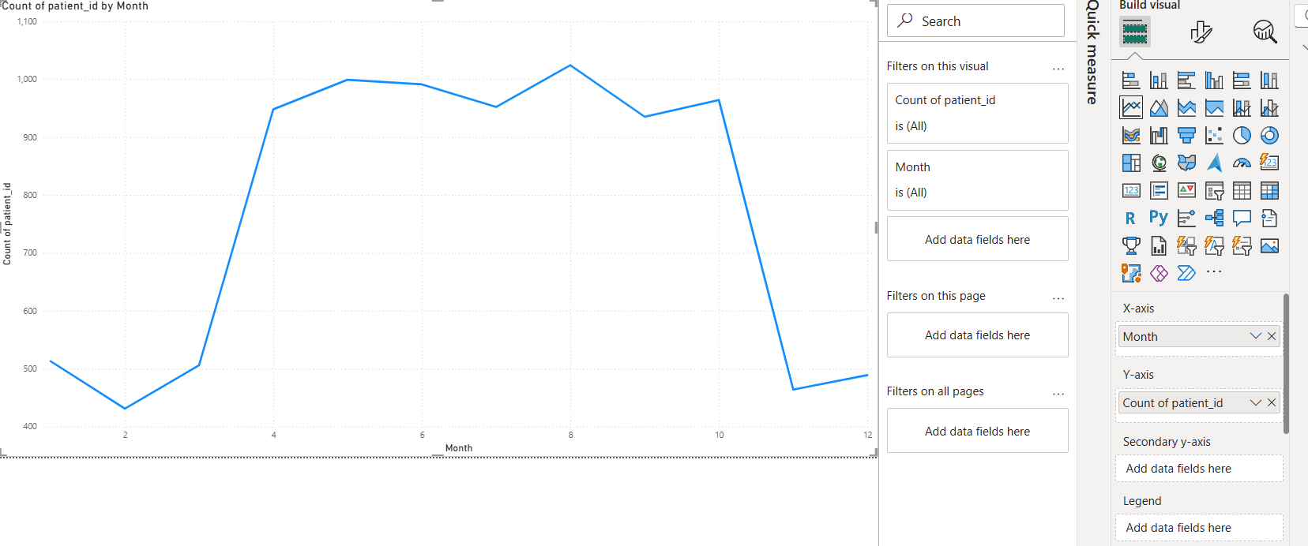

Observation:
- Patient visits are lowest in the early months (Jan–Feb).
- A sharp increase is observed from March onwards.
- The highest patient volume occurs during mid-year (May–August).
- A decline is seen towards the end of the year (Nov–Dec).
Insight:
- There is a clear seasonal trend in patient visits.
- Mid-year months experience higher patient inflow, possibly due to seasonal illnesses.
- Patient volume is not evenly distributed throughout the year.

Recommendation:
- Increase staff and resources during peak months (May–August).
- Plan maintenance and training during low-demand periods (Jan–Feb, Nov–Dec).
- Implement seasonal healthcare strategies to manage demand effectively.

4.Which age groups report the highest and lowest satisfaction scores?

Approach:
- A clustered column chart was created using Age Group on the X-axis and average patient satisfaction score on the Y-axis.
- This helps compare satisfaction levels across different age groups.
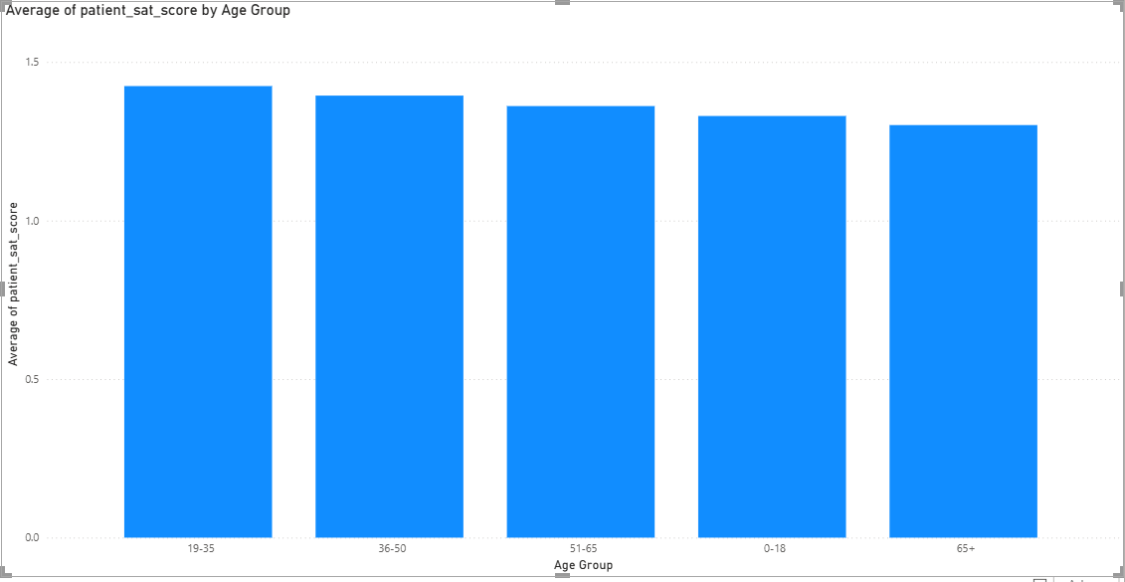

Observation:
- The 19–35 age group reports the highest satisfaction score (~1.4).
- The 65+ age group reports the lowest satisfaction score (~1.3).
- Other age groups show relatively similar satisfaction levels with slight variations.

Insight:
- Younger adults (19–35) appear more satisfied with hospital services.
- Satisfaction slightly decreases with increasing age.
- Elderly patients (65+) may have unmet expectations or require more specialized care.

Recommendation:
- Focus on improving services for older age groups, especially 65+ patients.
- Provide personalized care and support for elderly patients.
- Maintain service quality for younger age groups to sustain high satisfaction.

5.Say someone outside of the hospital claims that there is racial or gender-based discrimination in the hospital, how will you identify whether the claim was right or not?
Chart 1: Gender vs Satisfaction
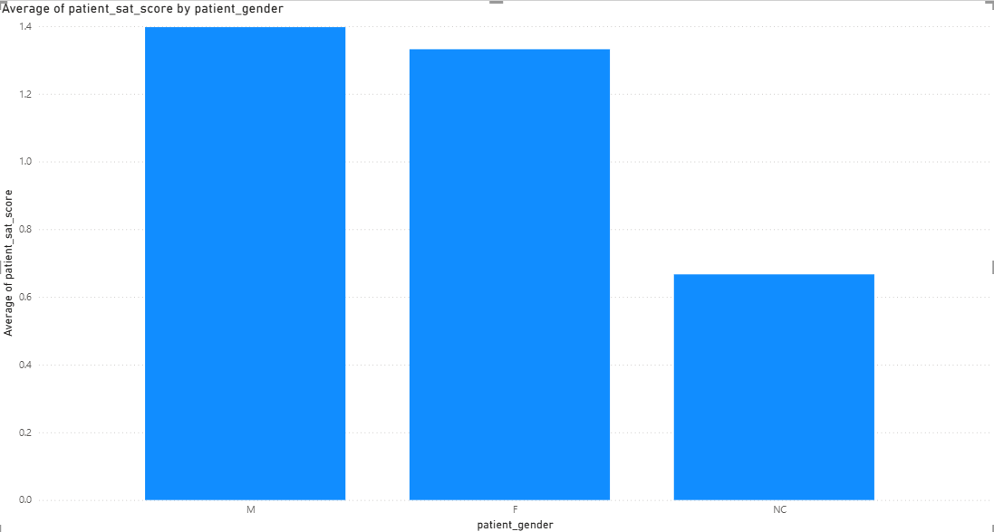

Observation:
- Male and Female satisfaction scores are similar
- NC group shows lower satisfaction

Insight:
- No major gender-based difference
- Lower satisfaction in NC may need further analysis

Chart 2: Race vs Satisfaction
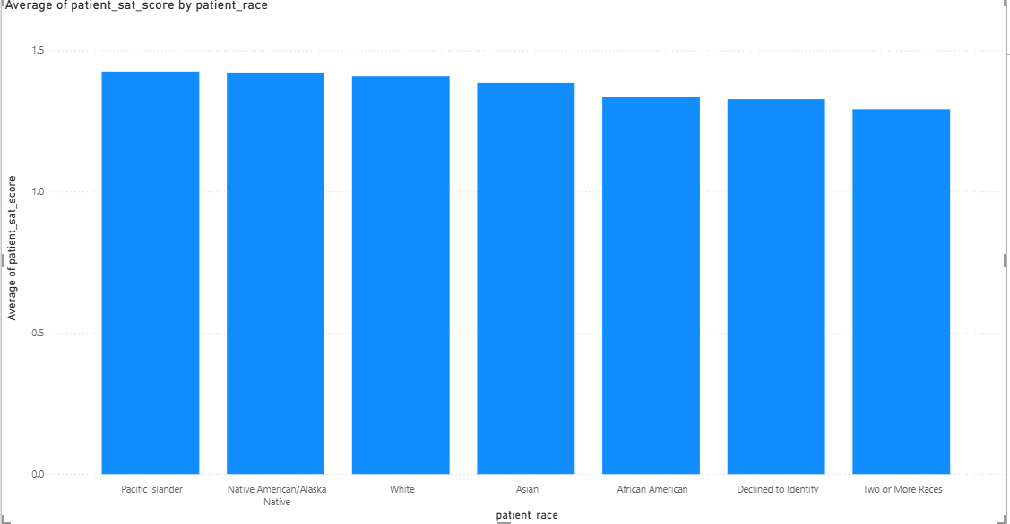

Observation:
- Satisfaction scores are almost equal across races

Insight:
- No strong evidence of racial discrimination
Chart 3: Gender vs Wait Time
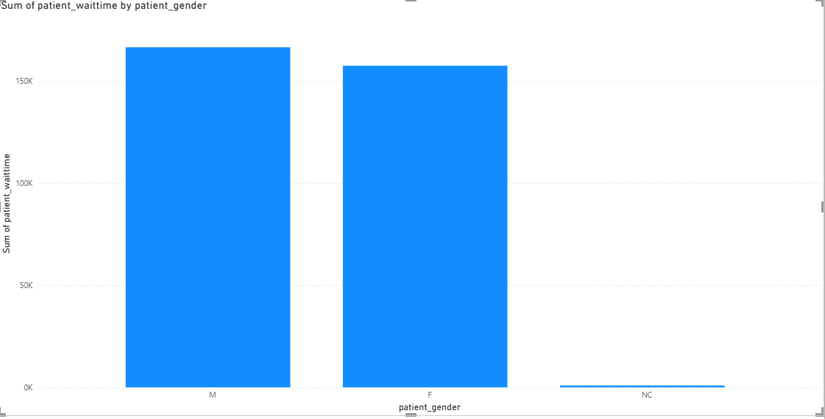

Observation:
- Slight variation in wait time between genders

Insight:
- Difference is minimal, not significant

Chart 4: Race vs Wait Time
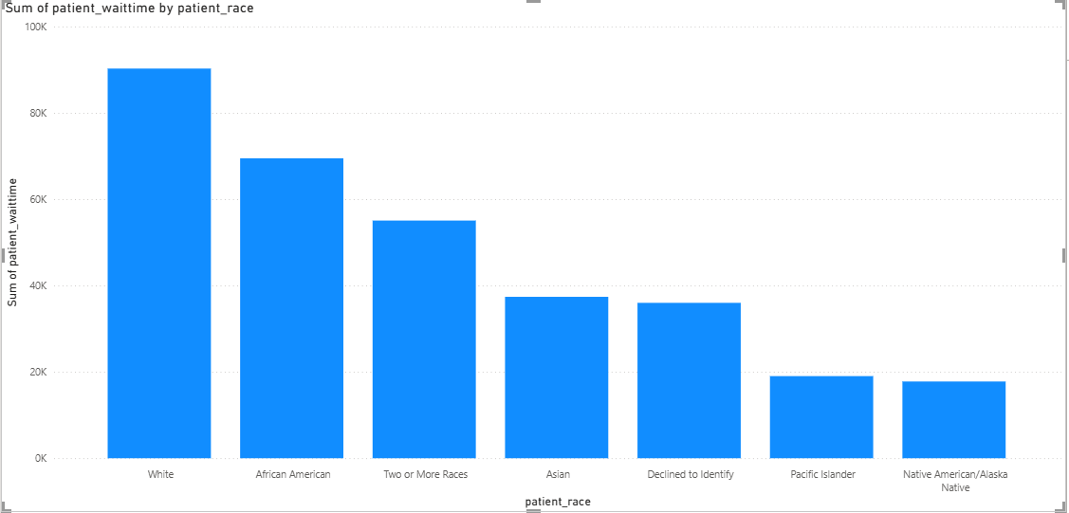

Observation:
- Some variation in wait time across races

Insight:
- No consistent pattern indicating bias

Conclusion
“Based on the analysis, there is no strong evidence of gender or racial discrimination as differences in satisfaction and wait time are minimal.”

6.The hospital management intends to offer discounts to patients. How should these offers/discounts be assigned to patients, on what basis, and why?

Approach:
- A Power BI dashboard was created using a scoring model based on patient wait time and satisfaction score.
- Patients were categorized into High, Medium, and Low discount groups.
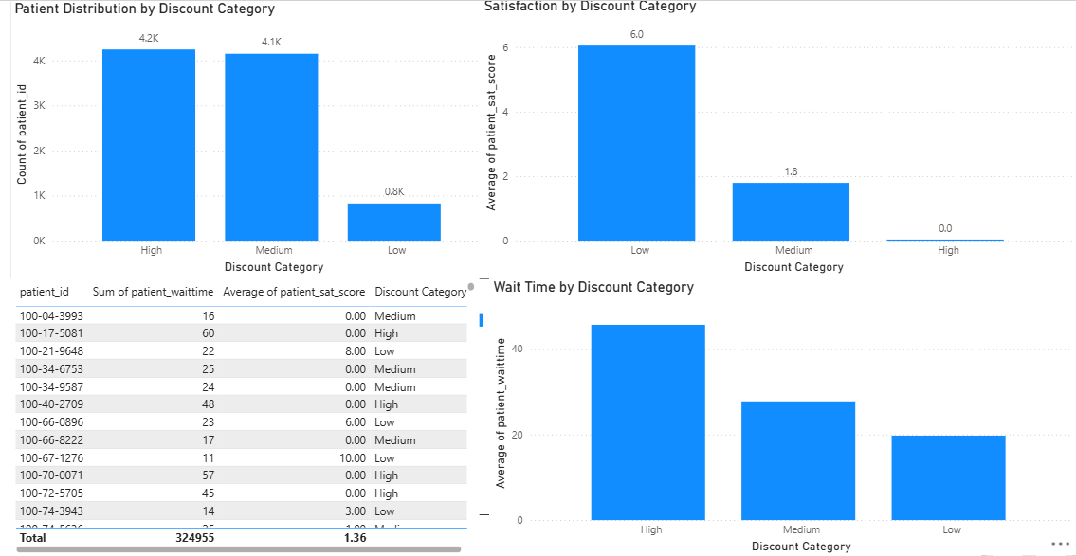

Observation:
- High category patients have the highest waiting time (~45 mins) and the lowest satisfaction (~0).
- Medium category patients have moderate waiting time and satisfaction levels.
- Low category patients have the lowest waiting time (~20 mins) and the highest satisfaction (~6).

Insight:
- Patients with poor experience (high wait time and low satisfaction) are correctly identified in the High discount category.
- Patients with better experience fall into the Low category and do not require discounts.

Recommendation:
- Offer maximum discounts to High category patients to improve their experience.
- Provide moderate incentives to Medium category patients.
- Avoid unnecessary discounts for Low category patients.
- Use a data-driven approach to ensure fair and efficient discount allocation.
“This data-driven approach ensures fair and efficient discount allocation.”

7.The hospital has a budget to hire 2-3 new doctors. They have asked for your suggestions on which departments they should hire.

Approach:
- A bar chart was created in Power BI using department_referral on the Y-axis and count of patient_id on the X-axis.
- This helps identify departments with the highest patient load.
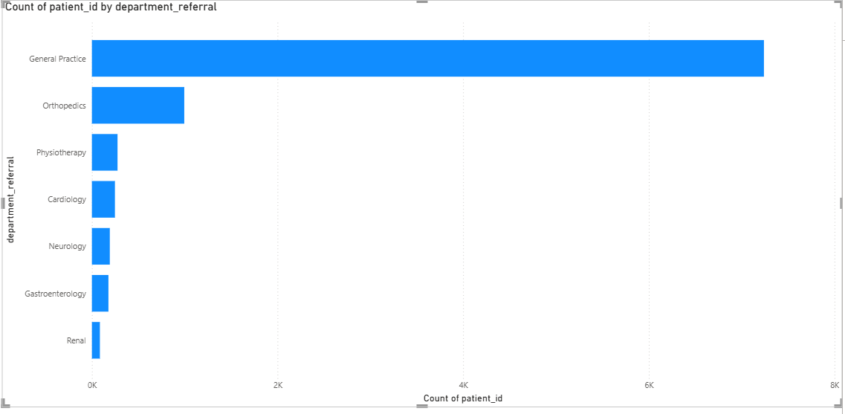

Observation:
- General Practice has the highest number of patient visits.
- Orthopedics has the second-highest patient volume.
- Other departments such as Cardiology, Neurology, and Gastroenterology have relatively lower patient counts.

Insight:
- Departments with higher patient volume are likely experiencing higher workload.
- General Practice and Orthopedics may be understaffed compared to patient demand.

Recommendation:
- Hire new doctors in General Practice as it has the highest demand.
- Allocate additional doctors to Orthopedics due to its relatively high patient volume.
- This will help reduce patient load, waiting time, and improve service quality.

8.Is the hospital profitable? How will you determine the profitability?

Approach:
- A Power BI chart was created using department_referral and sum of total_bill to analyze revenue generated by each department.
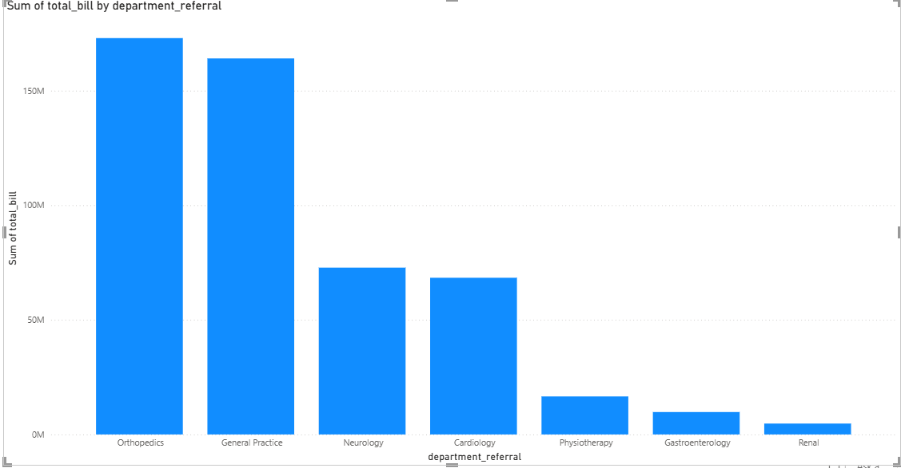

Observation:
- Departments like Orthopedics and General Practice generate the highest revenue.
- Other departments contribute comparatively less to total revenue.
Insight:
- The hospital is generating strong revenue, especially from high-demand departments.
- However, profitability cannot be fully determined due to the absence of cost data.

Recommendation:
- Focus on high-revenue departments such as Orthopedics and General Practice.
- Include cost-related data for accurate profitability analysis.
- Improve efficiency to maximize profits.

“The hospital appears to be generating strong revenue, but exact profitability cannot be determined without cost data.”

9.Any Department for which the waiting time is oddly large?

Approach:
- A clustered column chart was created using department_referral and average patient_waittime to identify departments with higher waiting times.
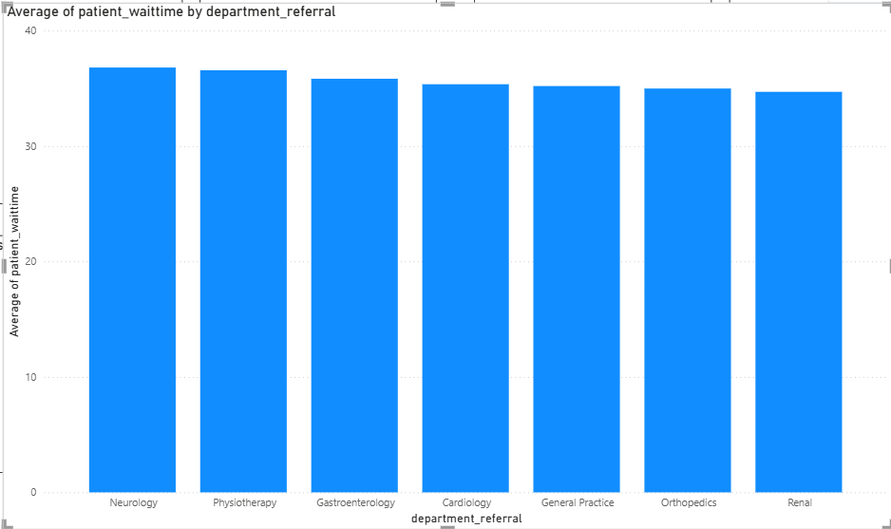

Observation:
- Departments such as General Practice and Orthopedics show relatively higher average waiting times compared to others.

Insight:
- Higher waiting times indicate heavy patient load or insufficient staff in these departments.

Recommendation:
- Allocate more resources or doctors to departments with high waiting times to improve efficiency and patient experience.
Conclusion:-
“No department shows an unusually high waiting time, as the average waiting time is relatively similar across all departments.”
Waiting time across departments is consistent
No extreme delays observed
Slight variations exist but not significant

10.Come up with strategies to provide discounts to the patients.

Approach:
- A Power BI dashboard was created using Discount Category based on patient wait time and satisfaction score.
- Clustered column charts were used to compare patient distribution, satisfaction, and waiting time across categories.
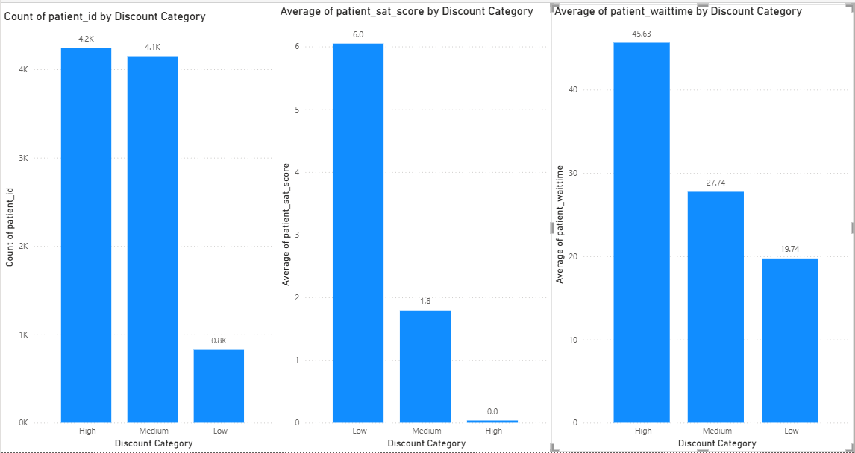

Observation:
- High category patients have the highest waiting time (~45) and lowest satisfaction (~0).
- Medium category patients show moderate waiting time (~27) and satisfaction (~1.8).
- Low category patients have the lowest waiting time (~20) and highest satisfaction (~6).

Insight:
- Patients with poor experience (high wait time and low satisfaction) fall into the High category.
- Patients with better experience fall into the Low category and do not require compensation.

Recommendation:
- Provide maximum discounts to High category patients.
- Offer limited discounts to Medium category patients.
- Avoid discounts for Low category patients and maintain service quality.

11.Say you need to align the doctors of the “General Practice” department to work in one of the two shifts, how will you identify what will these two shifts' timings be, and how will you divide the doctors in these two shifts? And also will this 2 shift policy be helpful for the hospital?

Approach:
- A line chart was created in Power BI using Month on the X-axis and count of patient_id on the Y-axis for the General Practice department.
- This was used to analyze variations in patient volume over time.

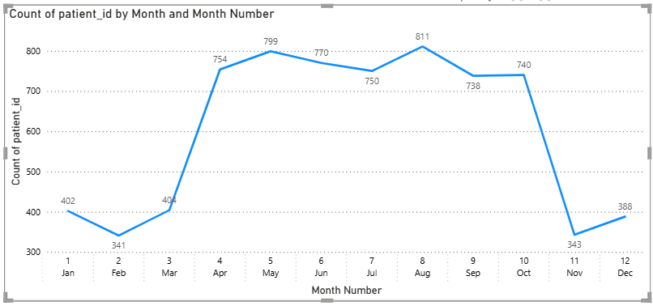

Observation:
- Patient visits fluctuate significantly across different months.
- Some months (e.g., August, May, June) show high patient volume (~750–800).
- Other months (e.g., November, February) show lower patient volume (~340–400).

Insight:
- Patient demand is not consistent throughout the year.
- Certain periods experience high workload, while others are relatively less busy.
- This uneven distribution indicates the need for flexible doctor scheduling.

Recommendation:
- Divide doctors into two shifts (morning and evening) to handle varying patient load.
- Allocate more doctors during high-demand periods and fewer during low-demand periods.
- The 2-shift policy will help reduce waiting time, balance workload, and improve patient satisfaction.

12.What do you understand by PowerBI gateway? What are its use cases?
Power BI Gateway is a secure bridge that allows Power BI Service (cloud-based platform) to connect with on-premises data sources such as local databases, Excel files, or servers.
Normally, Power BI Service runs on the cloud and cannot directly access data stored inside an organization’s local network. The Gateway solves this problem by enabling a secure and controlled connection between cloud and local data without exposing sensitive data to the internet.

Types of Gateway:
- Personal Mode
  - Used by individual users
  - Supports only Power BI
  - Ideal for personal reports and small use cases
- Standard Mode (Enterprise Mode)
  - Used by organizations/teams
  - Supports Power BI, Power Apps, Power Automate
  - Allows multiple users and shared datasets

Use Cases:

1. Scheduled Data Refresh
- Automatically refresh reports and dashboards from on-premise data
- Example: Daily refresh of hospital patient data

2. Live / Direct Query Connection
- Enables real-time data access without storing data in Power BI
- Useful for up-to-date dashboards

3. Secure Data Transfer
- Data is encrypted and transferred securely
- No need to expose internal servers to the internet

4. Centralized Data Access
- Multiple users can access shared datasets through one gateway
- Improves collaboration

5. Integration with Microsoft Tools
- Works with Power BI, Power Apps, and Power Automate
- Enables automation and workflow integration

13.How would you approach this problem, if the objective and subjective questions weren't given?

Approach:
- If objective and subjective questions were not provided, I would start by understanding the dataset and identifying key fields such as patient demographics, department, wait time, satisfaction, and billing.
- Then, I would perform exploratory data analysis (EDA) in Power BI using various visualizations.
Observation:
- Analyze trends such as patient visits over time, department-wise distribution, and demographic patterns.
- Identify key metrics like average wait time, satisfaction scores, and revenue.
- Detect patterns, outliers, and relationships between variables.

Insight:
- Derive meaningful insights such as which departments are busiest, which patients are less satisfied, and where inefficiencies exist.
- Understand how different factors (age, gender, wait time) affect hospital performance.
Recommendation:
- Based on insights, suggest improvements such as optimizing staff allocation, reducing waiting time, and improving patient satisfaction.
- Build an interactive dashboard to help stakeholders make data-driven decisions.

14.Can you analyze and write the type of relationship between the doctor id and department, is it one-to-one?

Approach:
- The relationship between doctor_id and department_referral was analyzed using the dataset in Power BI.
- By observing the data, it was checked whether each doctor is linked to only one department or multiple departments.
Observation:
- A single doctor_id appears multiple times in the dataset.
- Each doctor is associated with only one specific department.
- However, one department contains multiple doctors.

Insight:
- The relationship between doctor_id and department is not one-to-one.
- It is a many-to-one relationship, where many doctors belong to one department.

Conclusion:
- The relationship is many-to-one (doctor → department).
- Therefore, it is not a one-to-one relationship.

Main Dashboard
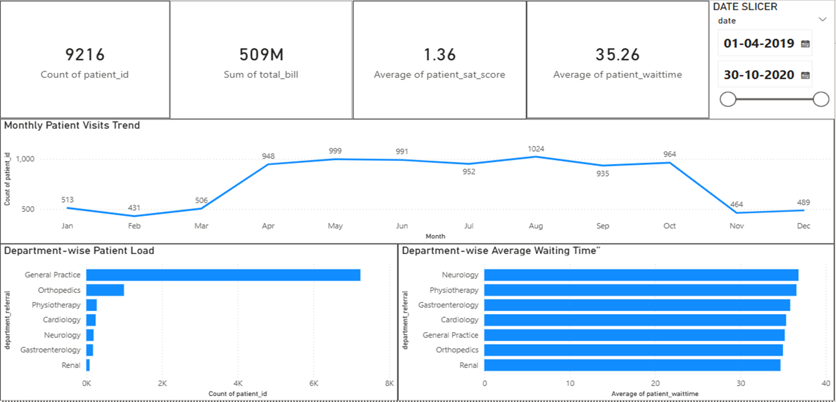
Doctors Dashboard
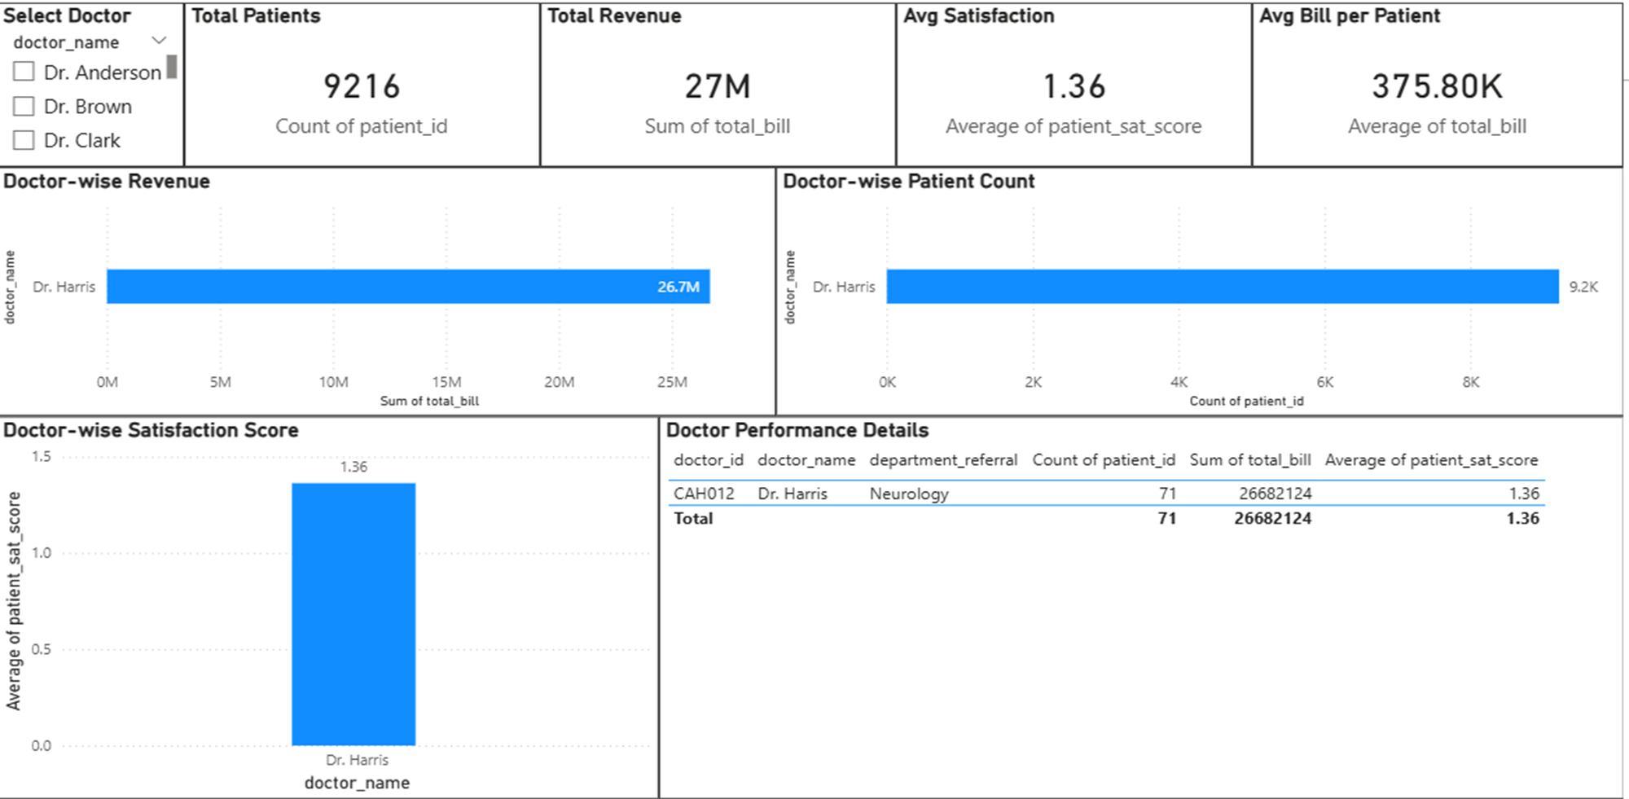

Patients Dashboard
